Bharat ShikshanPrasarak Mandal, Saoli
RASHTRAPITA MAHATMA GANDHI
ARTS, COMMERCE & SCIENCE COLLEGE, SAOLI
Tah. Saoli, Distt. Chandrapur (M.S.) 441 225
Accredited by NACC with B-Grade (CGPA-2.33)
rmgmiqac@gmail.com Mr.Devilal N Watakhere
dnwatakhere23@rediffmail.com IQAC Coordinator
www.rmgcollege.com Cell. 8888862289
Fax. 07174-274538 Tel. 07174-274538

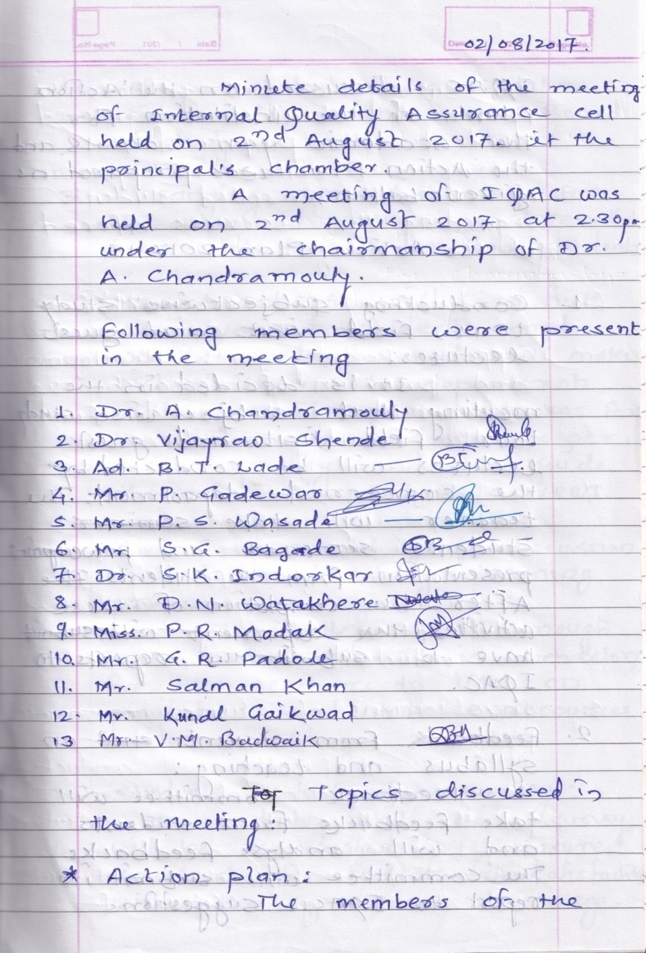
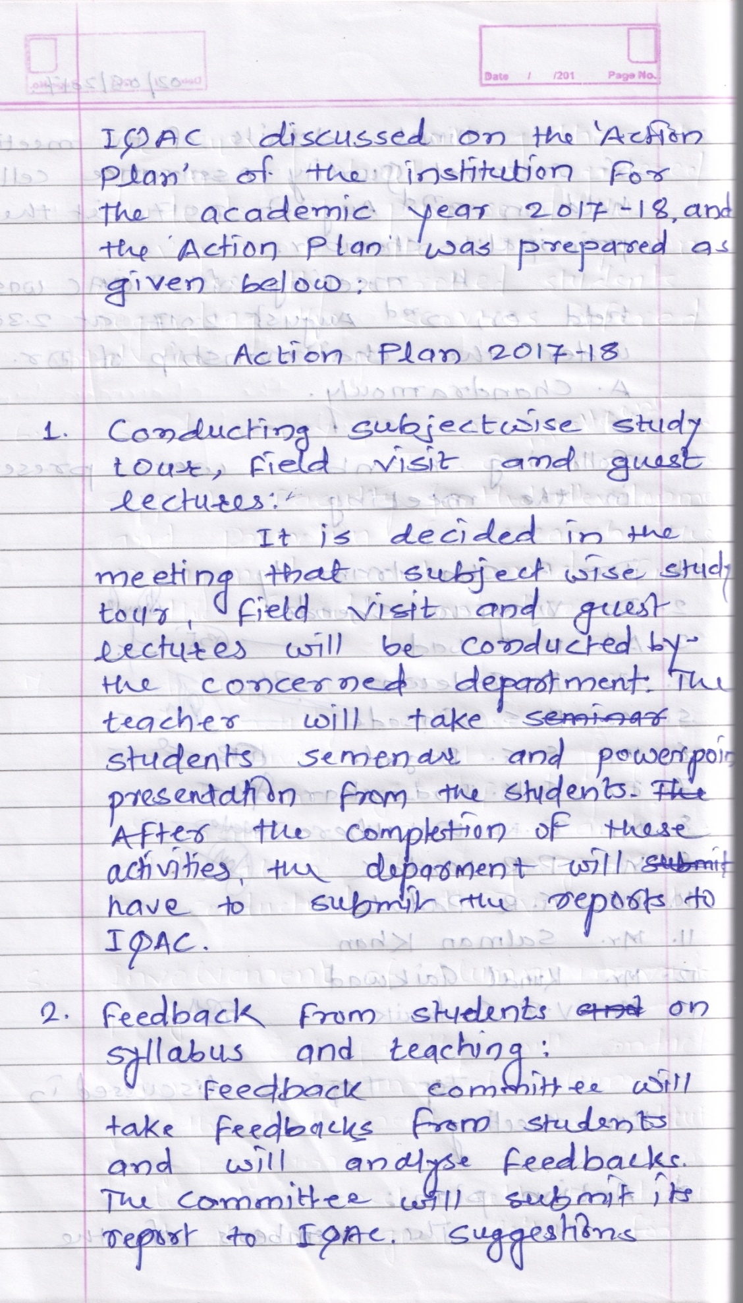

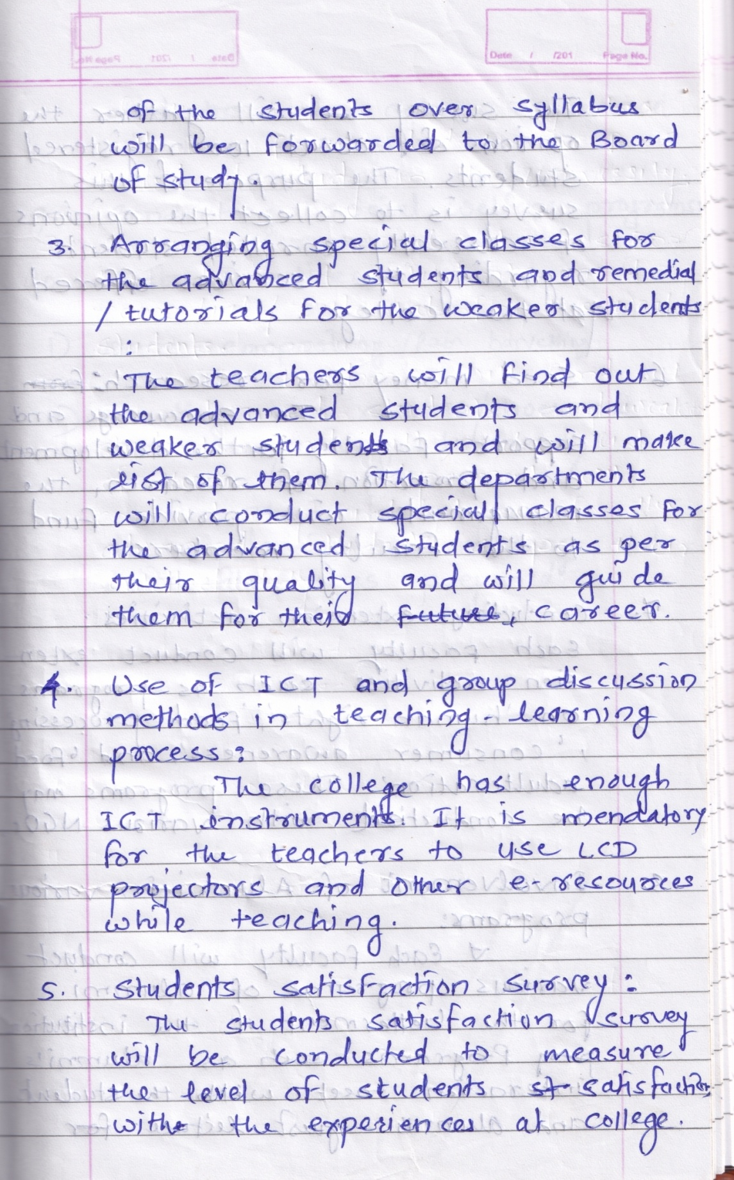

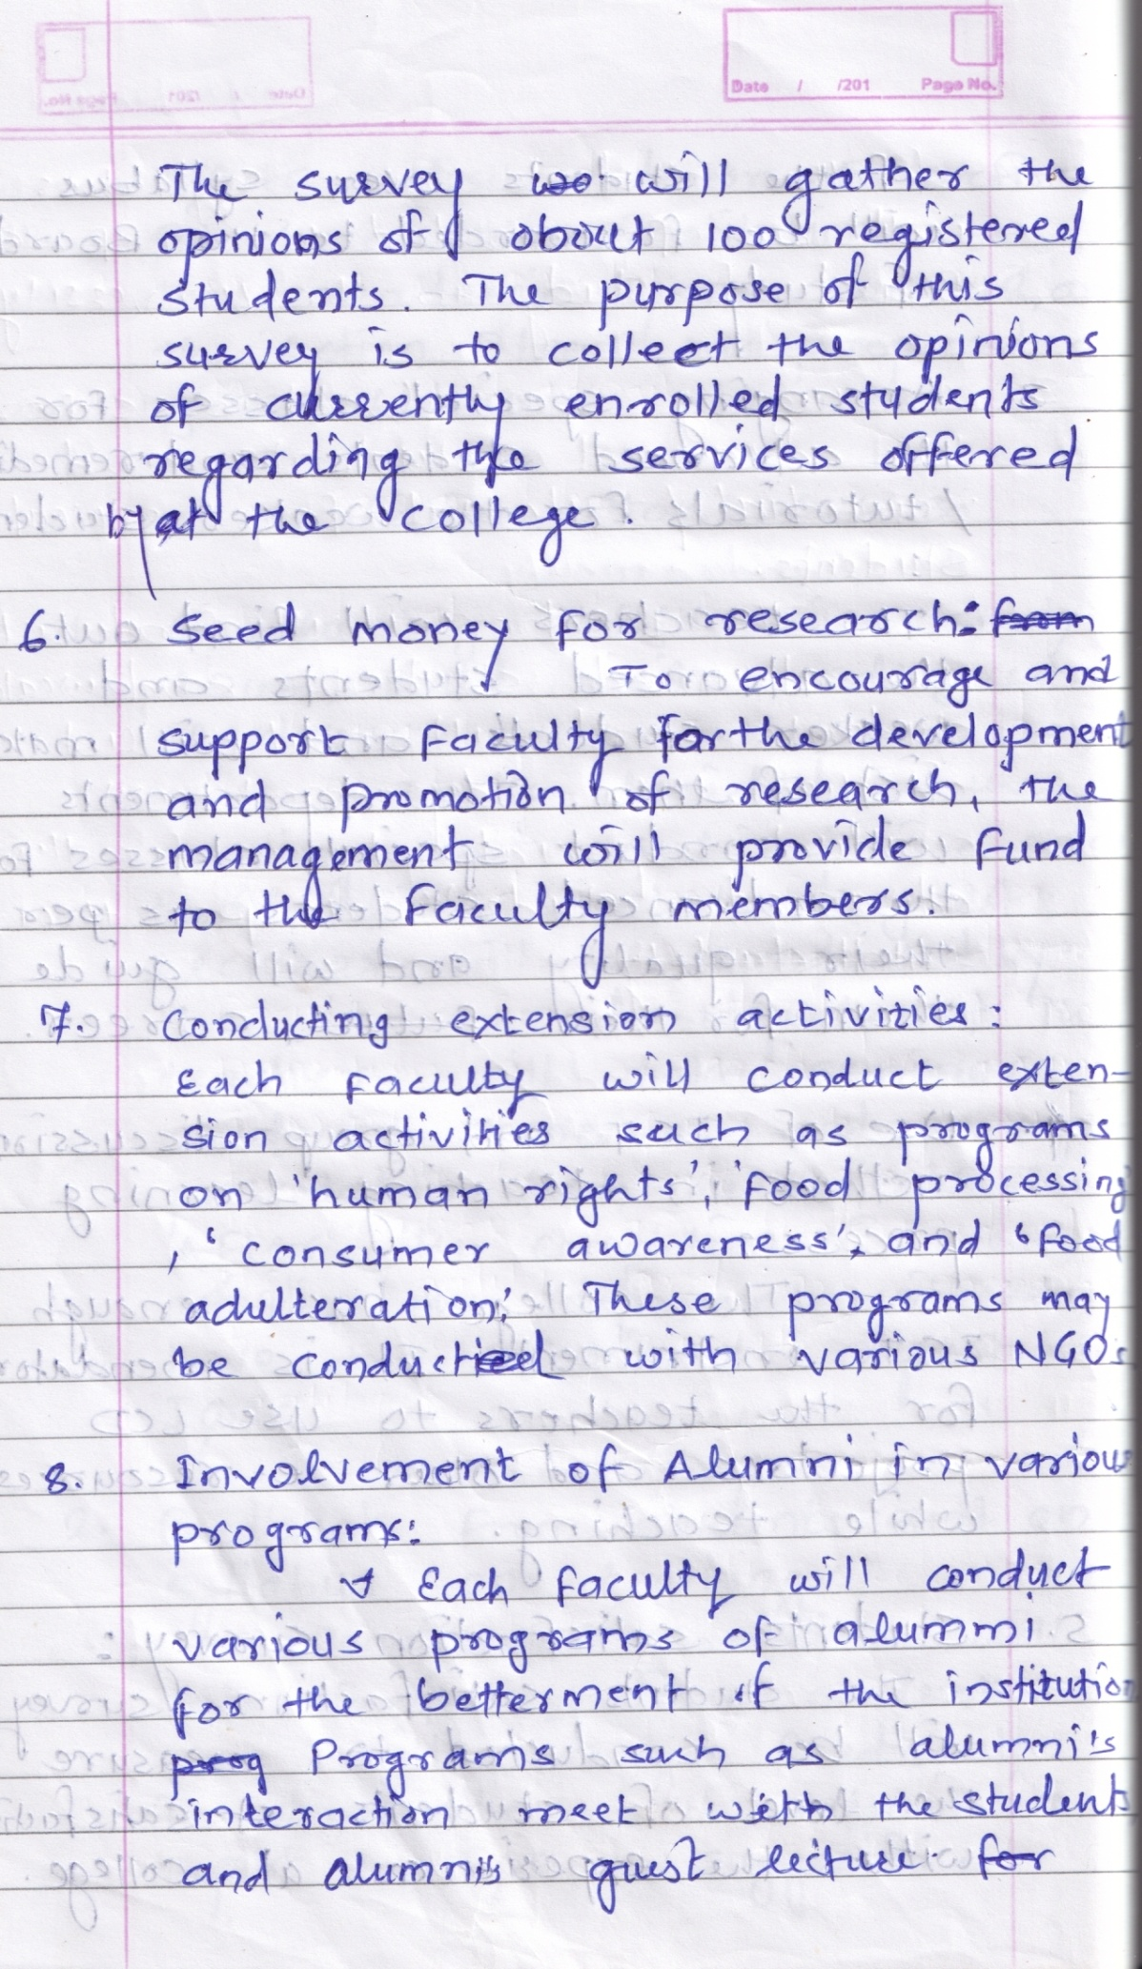

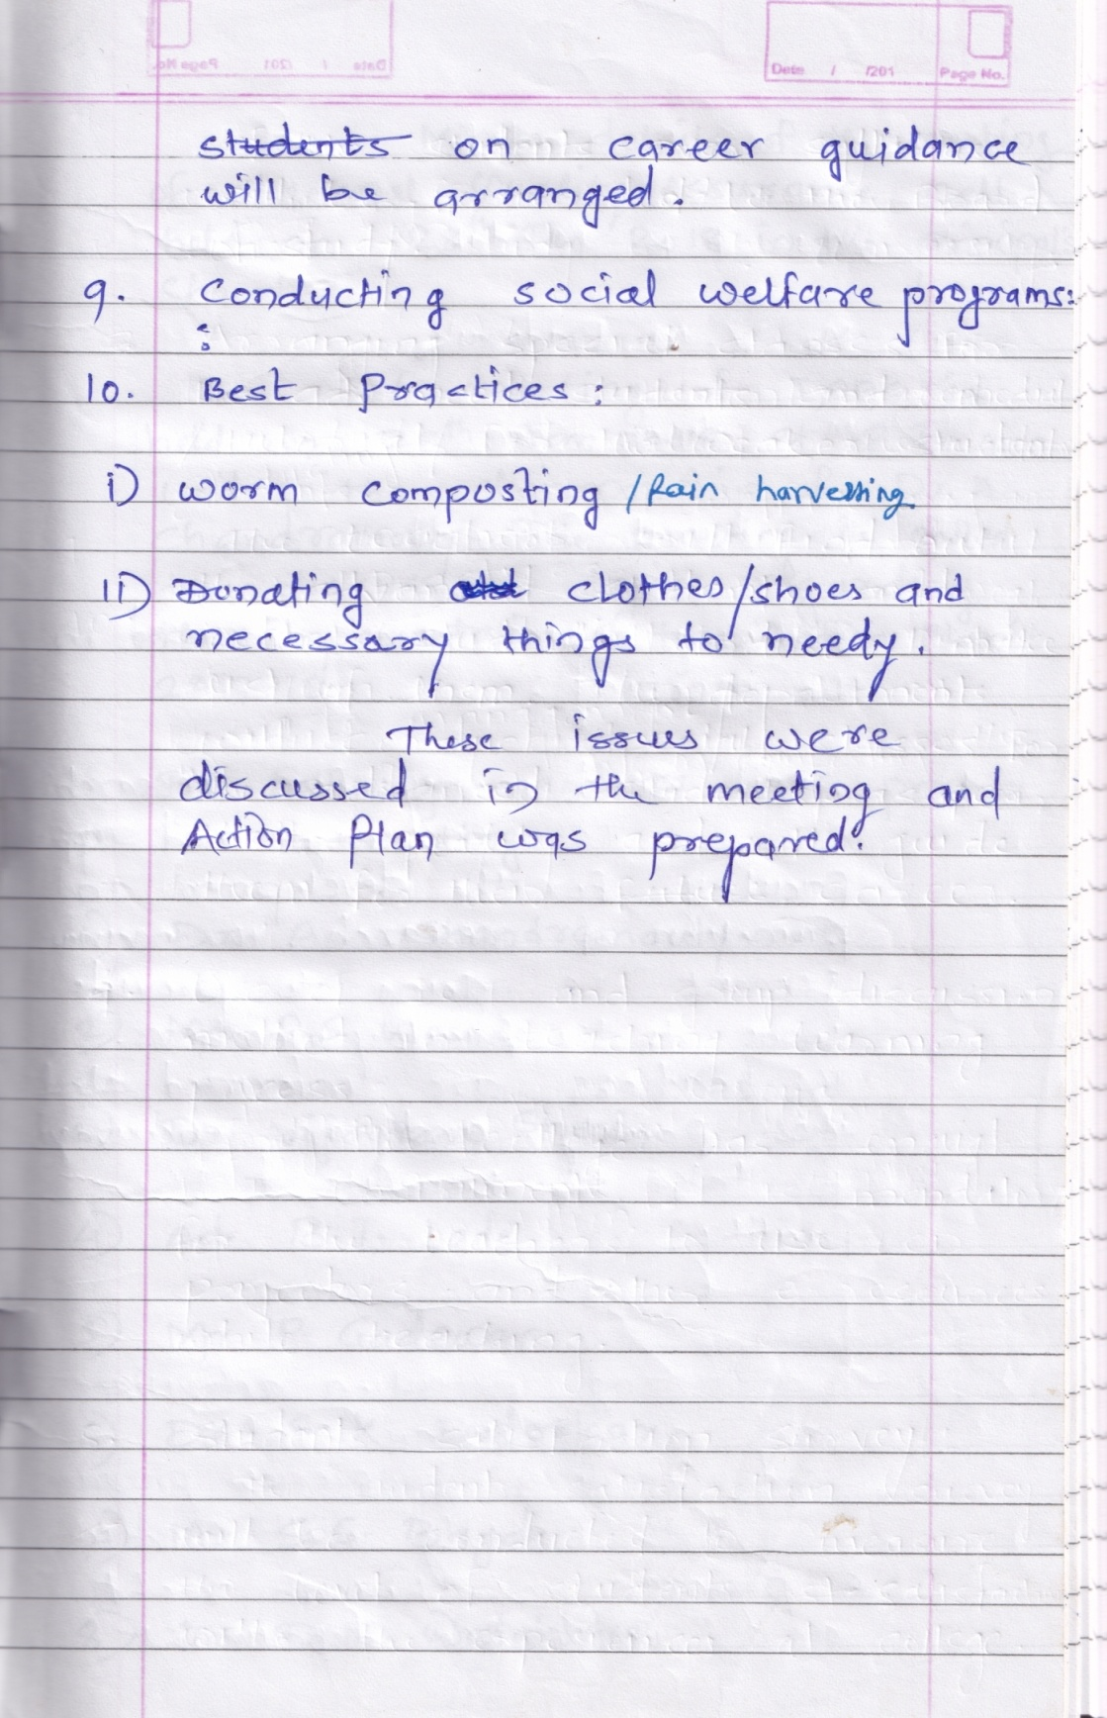

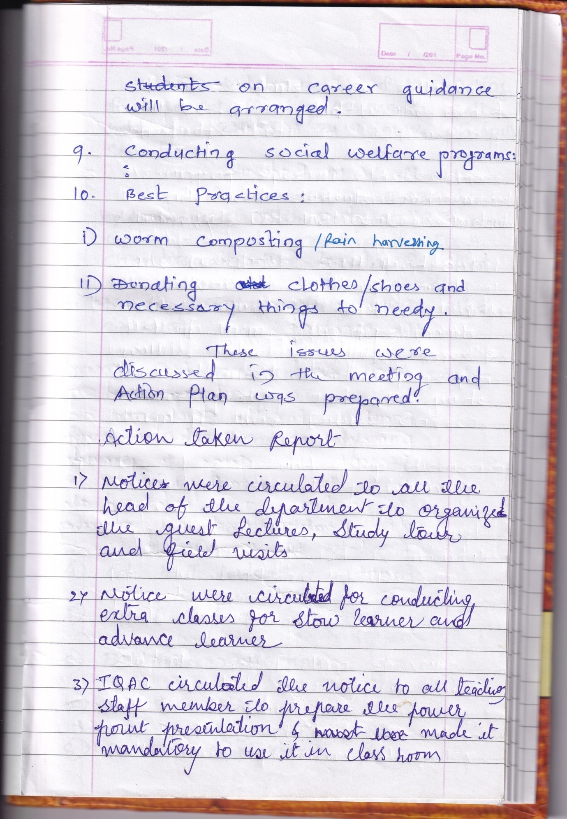

Bharat ShikshanPrasarak Mandal, Saoli
RASHTRAPITA MAHATMA GANDHI
ARTS, COMMERCE & SCIENCE COLLEGE, SAOLI
Tah. Saoli, Distt. Chandrapur (M.S.) 441 225
Accredited by NACC with B-Grade (CGPA-2.33)
rmgmiqac@gmail.com Mr.Devilal N Watakhere
dnwatakhere23@rediffmail.com IQAC Coordinator
www.rmgcollege.com Cell. 8888862289
Fax. 07174-274538 Tel. 07174-274538

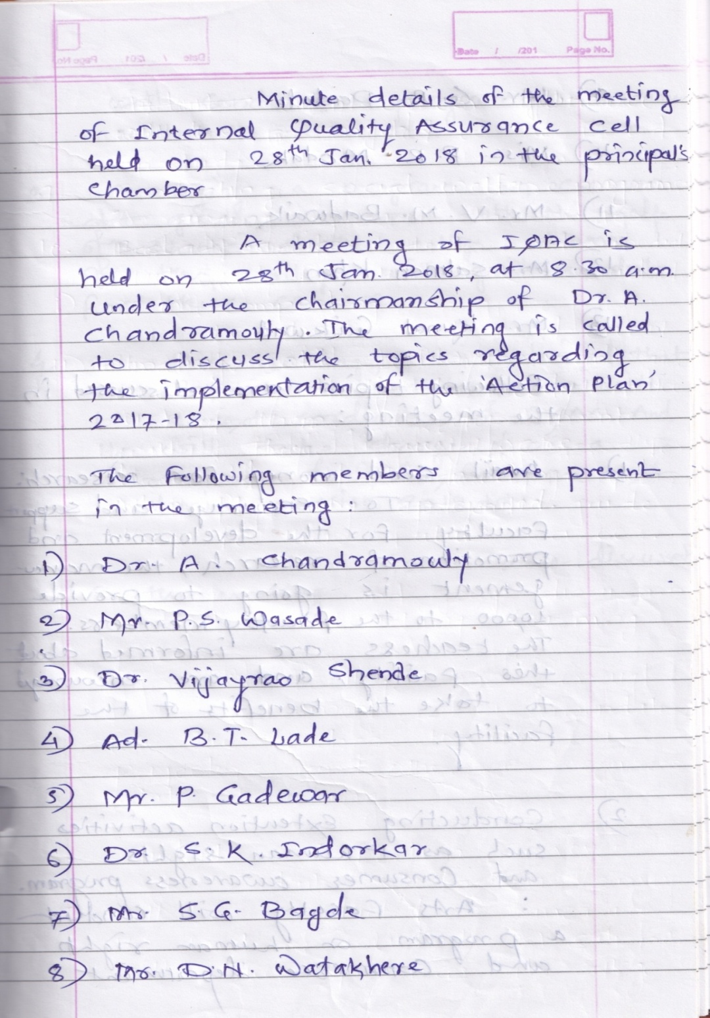
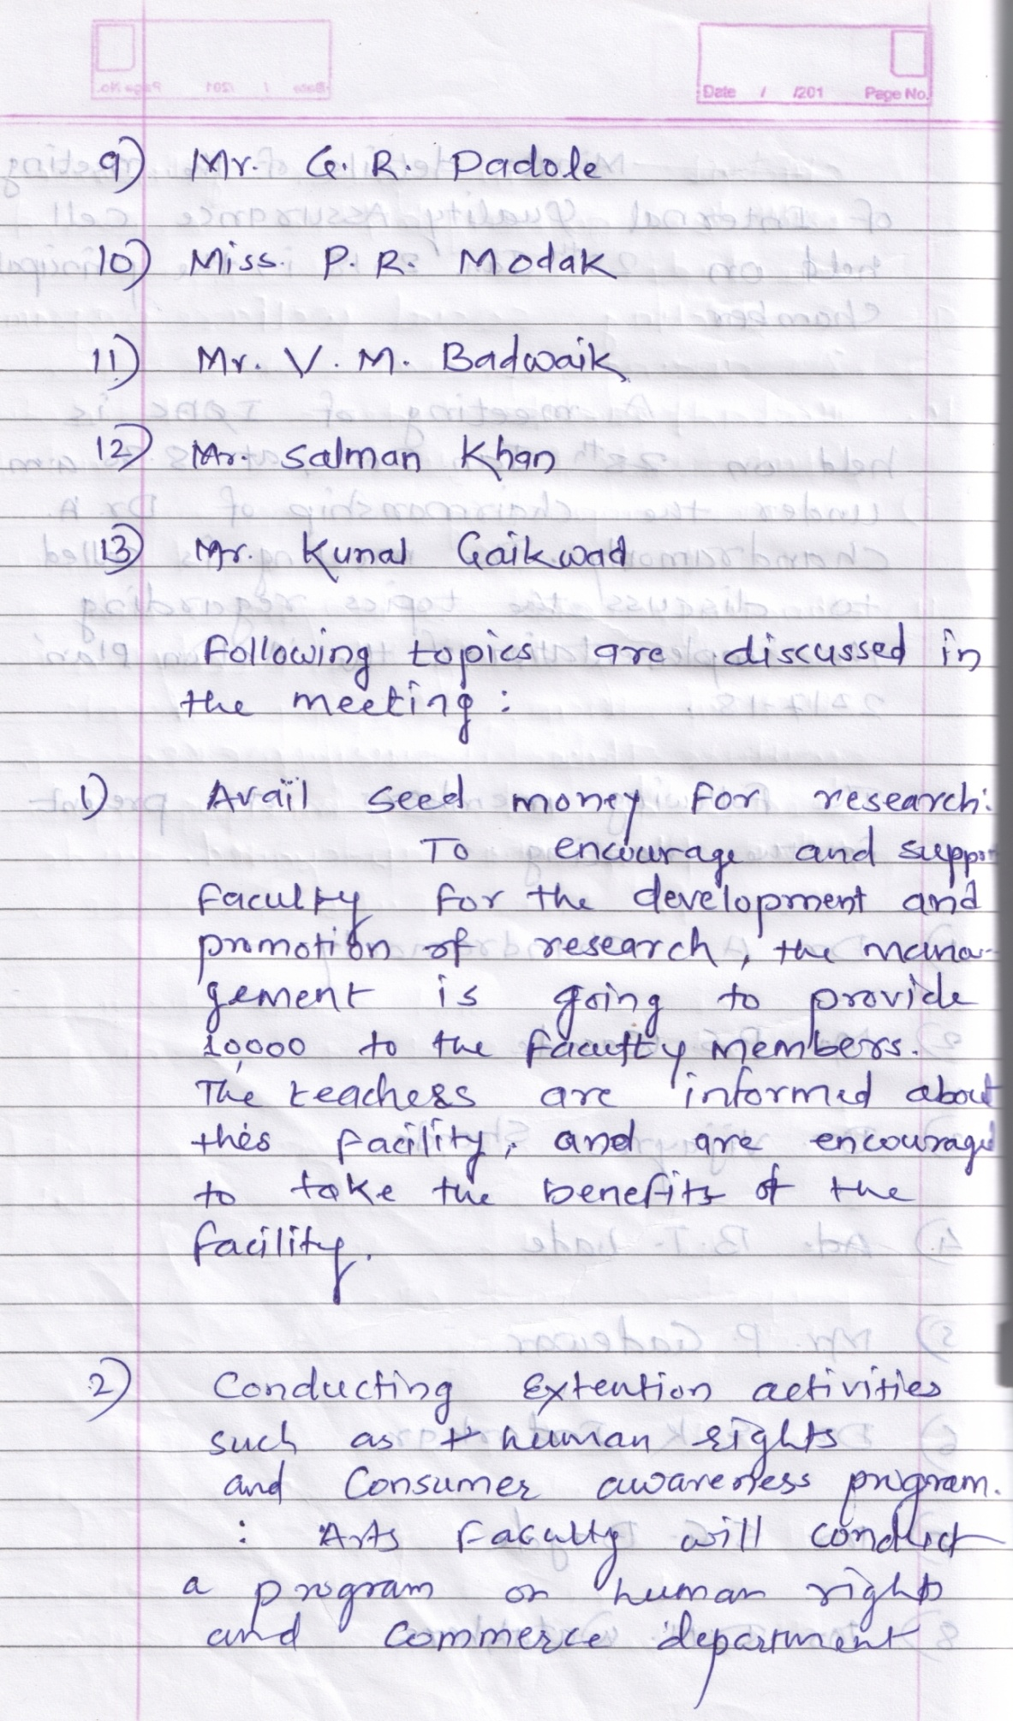

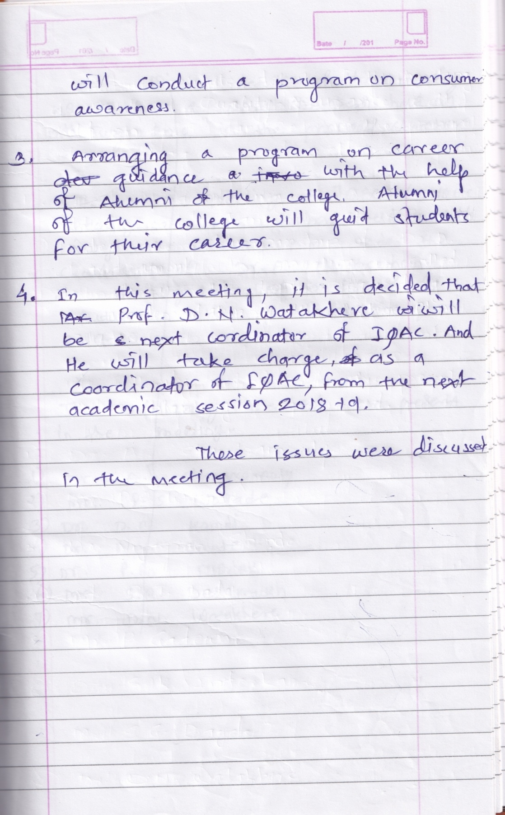

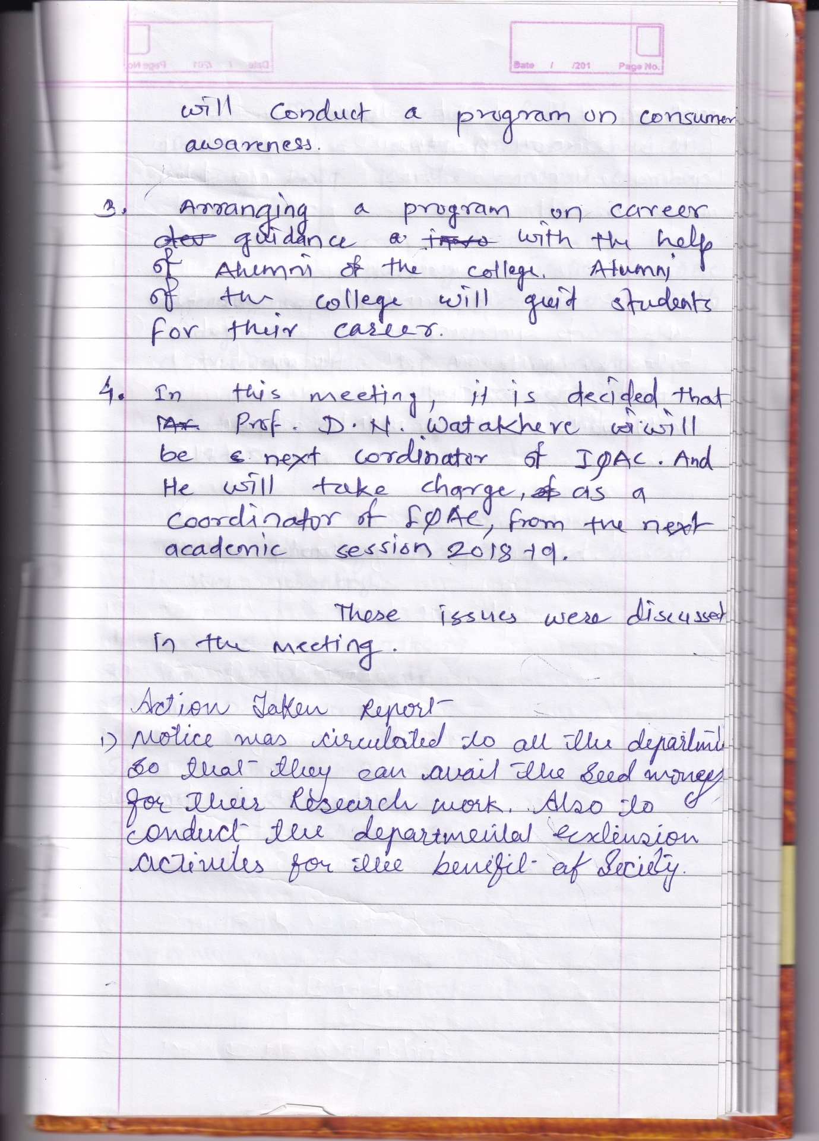

Bharat ShikshanPrasarak Mandal, Saoli
RASHTRAPITA MAHATMA GANDHI
ARTS, COMMERCE & SCIENCE COLLEGE, SAOLI
Tah. Saoli, Distt. Chandrapur (M.S.) 441 225
Accredited by NACC with B-Grade (CGPA-2.33)
rmgmiqac@gmail.com Mr.Devilal N Watakhere
dnwatakhere23@rediffmail.com IQAC Coordinator
www.rmgcollege.com Cell. 8888862289
Fax. 07174-274538 Tel. 07174-274538
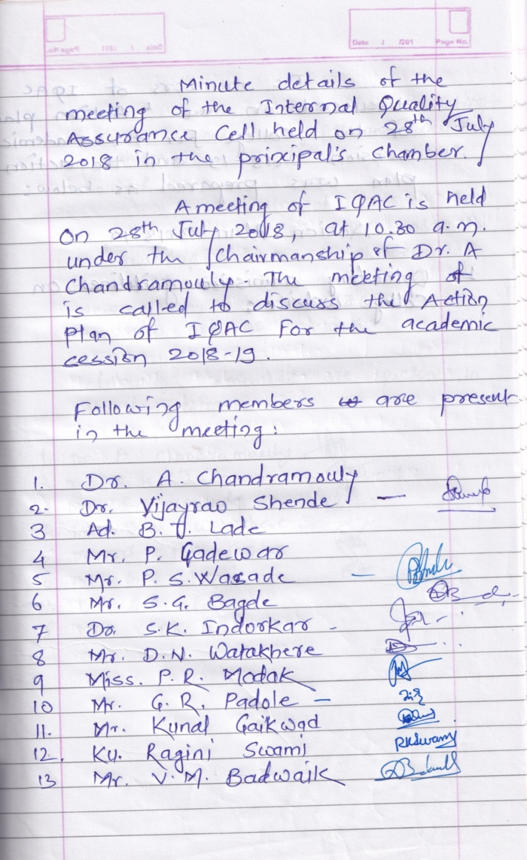
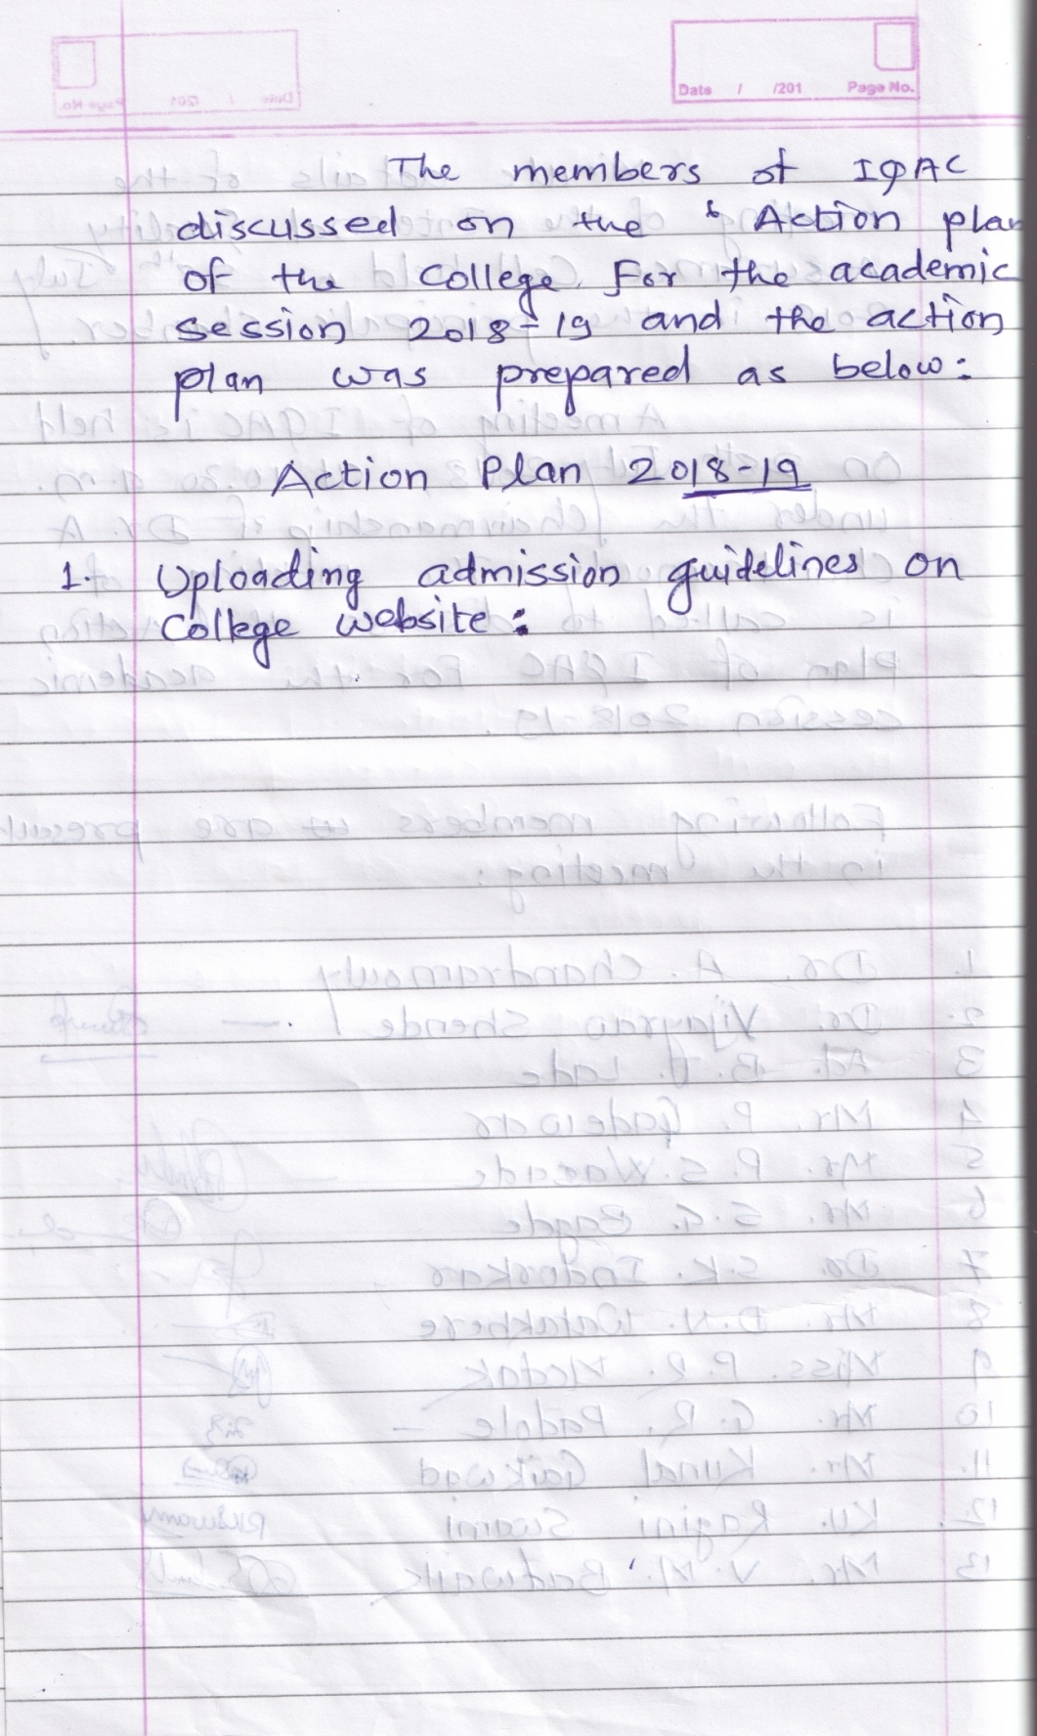

Bharat ShikshanPrasarak Mandal, Saoli
RASHTRAPITA MAHATMA GANDHI
ARTS, COMMERCE & SCIENCE COLLEGE, SAOLI
Tah. Saoli, Distt. Chandrapur (M.S.) 441 225
Accredited by NACC with B-Grade (CGPA-2.33)
rmgmiqac@gmail.com Mr.Devilal N Watakhere
dnwatakhere23@rediffmail.com IQAC Coordinator
www.rmgcollege.com Cell. 8888862289
Fax. 07174-274538 Tel. 07174-274538

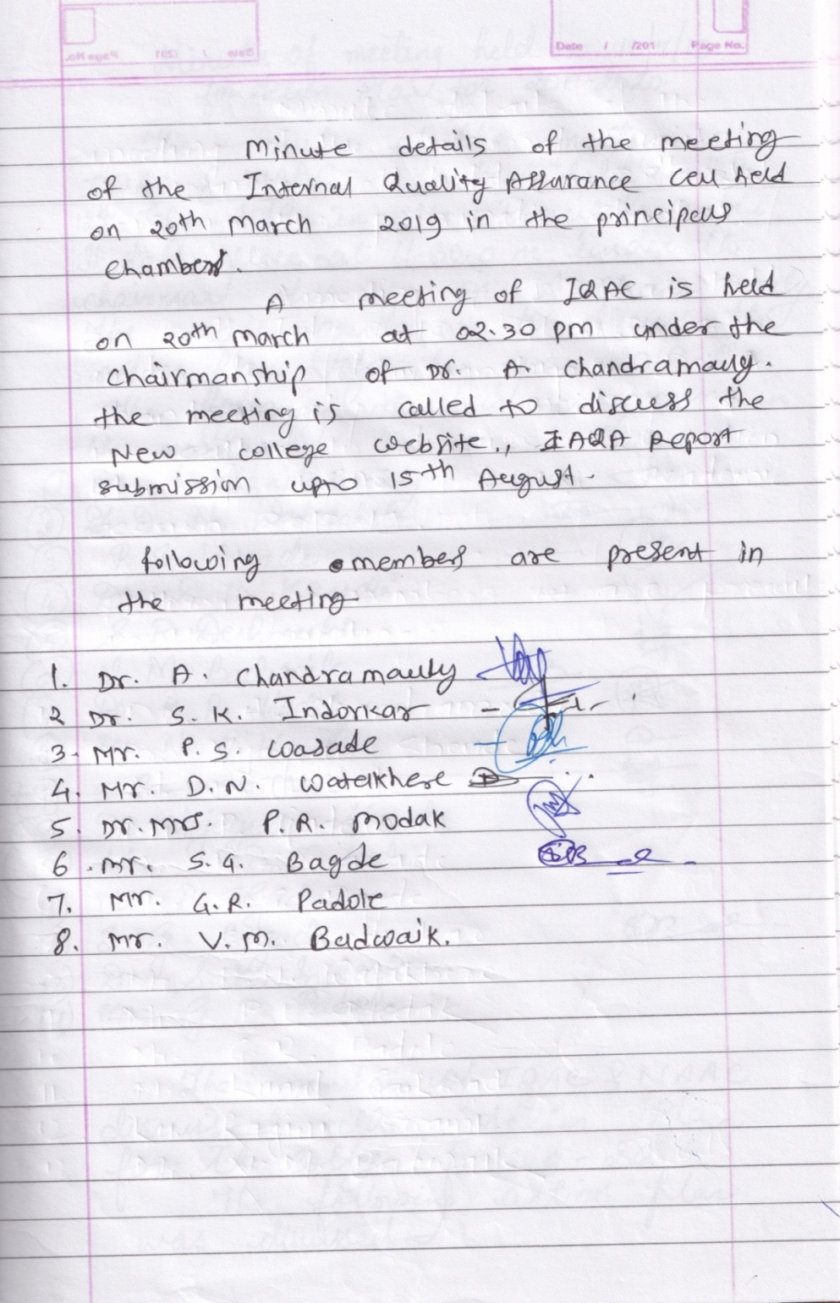

Bharat ShikshanPrasarak Mandal, Saoli
RASHTRAPITA MAHATMA GANDHI
ARTS, COMMERCE & SCIENCE COLLEGE, SAOLI
Tah. Saoli, Distt. Chandrapur (M.S.) 441 225
Accredited by NACC with B-Grade (CGPA-2.33)
rmgmiqac@gmail.com Mr.Devilal N Watakhere
dnwatakhere23@rediffmail.com IQAC Coordinator
www.rmgcollege.com Cell. 8888862289
Fax. 07174-274538 Tel. 07174-274538

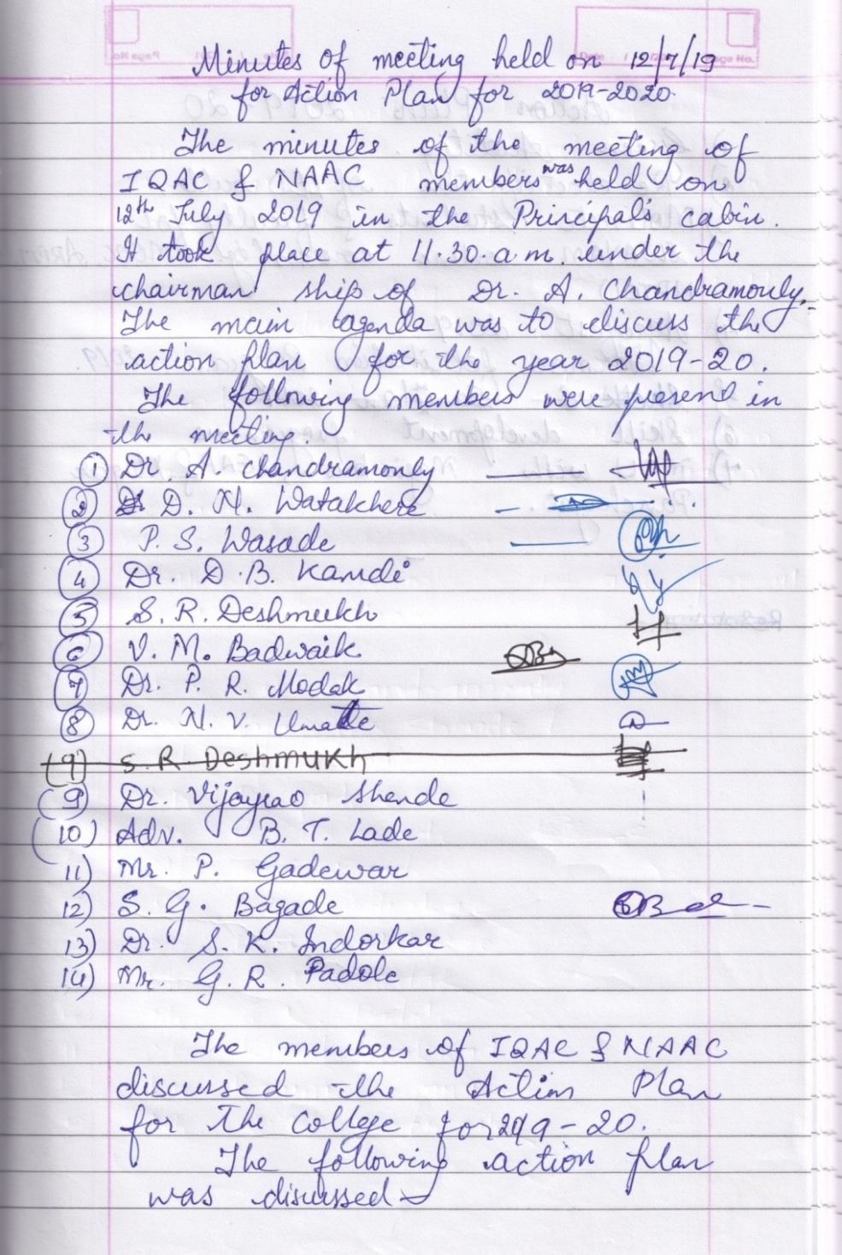

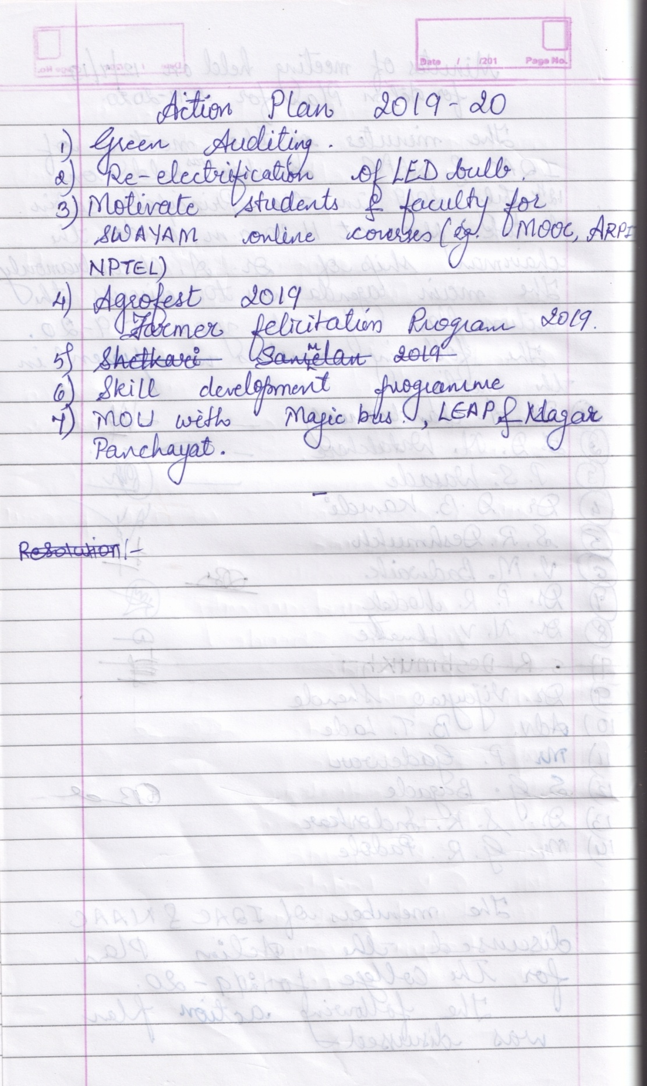

Mr. Devilal N Watakhere IQAC COORDINATOR

