Cloth Bank:
Our College has came up with a unique initiative called the Clothes Bank. Many people just throw their old clothes away. Old pair of jeans which one no longer fits in, an ancient sweater with some wool pulled off, a ragged t-shirt and all such clothing we abandon and move up to the latest fashion. You might want to donate, but the problem is how to find people who need such clothes So, we distributed the Handbills in the village with the help of Cloth Bank Volunteers (Students of NSS). The announcement were made in the Saoli city with help of sound system to inform the people about Cloth Bank initiative. Bank collects clothes from people who no longer need them, and distributes these clothes to the poor and the needy. It’s a brilliant idea and leaves one wondering as to why such an idea was not already implemented.

Object of Cloth Bank
Our basic idea is to collect old clothes that can be still be used and make those available to the needy free of cost through our institution which are working for the betterment of the society and always looking for solutions of problems in this near by areas. As our college comes in the rice belt of Maharashtra we observed that paddy field workers especially women needed pants and shirts so we came up with the solution to provide the pants shirts to such field workers and then we came up with the concept of cloth bank.
Initiation of Practice:
The Cloth Bank was established on 07-09-2017.Initially a committee was formed which comprises three teaching and one non-teaching staff. This committee went to local area created awareness among people to donate their old reusable cloths. We stored collected cloth in the college room. The Clothing Bank has been operating from two years and we’ve now reached a stage of maturity. We have a model that proves the deep impact it has on people’s lives, every day. We have many women and men who have become role models and are positively influencing their families and communities.
Cloth Bank Committee:
1.Dr.A.Chandramouly Chairman
2.Mr.P.S.Wasade Coordinator
3.Mrs. M.D.Bhakare Member
4.Mrs.N.V.Umate Member
5.Mr.Ramchandra D. Satak Non-Teaching Member

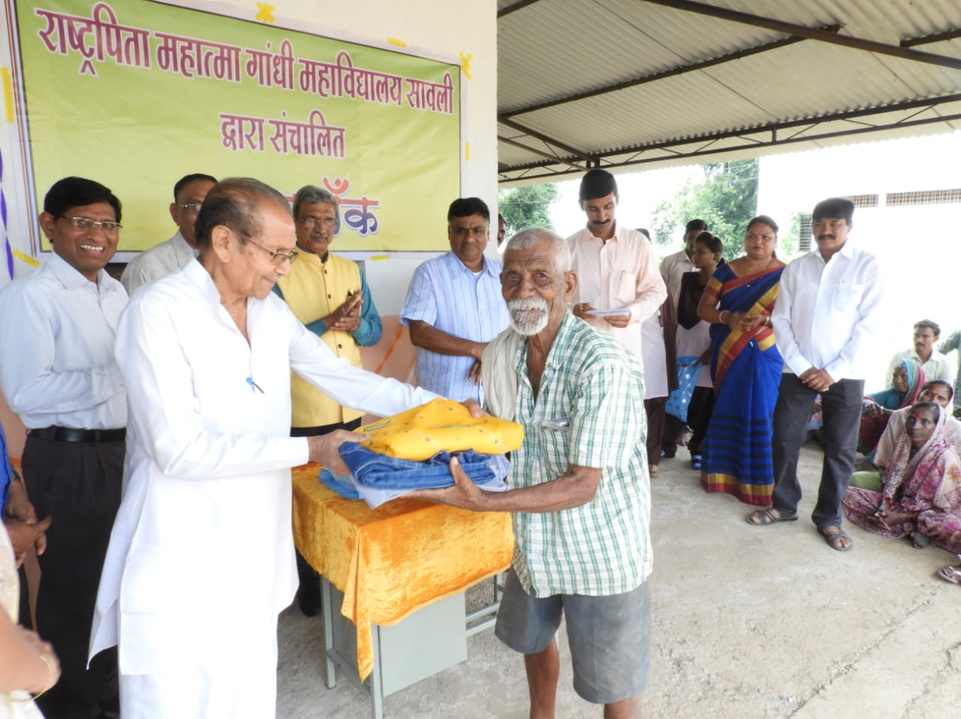
Picture: Honourable Secretary of BSPM Saoli distributing clothes to needy people along with Dr.A Chandramouly Principal,Prof.A.T.khobragde,Dr. Chandrashekhar Bhusari Pro.Vice Chancellor GU Gadchiroli, Sandipbhau Gaddamwar President BSPM Saoli, Prof.P.S.Wasade, Dr.Mrs.N.V.Umate, Prof.B.Sukare,

