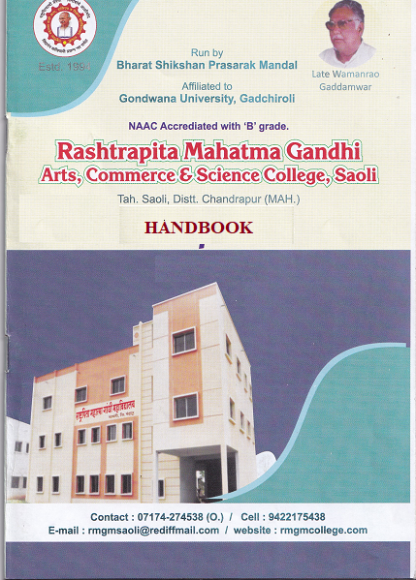

Code of Conduct
1) For Students
- 75% attendance is compulsory for all subjects.
- Students should be present in uniform and ID card in Campus.
- Students should follow university ordinance.
- Ragging is prohibited inside and outside the premises of the college.
- Students should behave politely and courtesy
- Prohibition of Tobacco, Liquor, Cigarette and Unethical behavior inside the campus.
- Students should be present in classroom before the teacher comes and leave the classroom after the teacher leaves.
- If any Leisure class, students should utilize the time in library.
- Students should strictly obey the discipline norms of the institute and do not behave to defame the same.
- Students should not be involved in any act which defames the dignity of the institution.
- Students should be present for the daily prayer.

2) For Teachers
- For Improving the results and merit teacher should conduct 4 unit tests and one Preliminary tests in each session.
- Remedial Classes for weak students in Unit Tests as well as Preliminary exams.
- Once in a month Subject Guest Lecture should be arranged and Orientation program for Students Personality Development should be Conducted.
- To in crease interest among students organize subject study circle.
- To enhance interest among students teacher should give First Second Pries to the Subject Toppers.
- Teacher should update daily dairy and endorsed by Principal.
- Teacher should involve in Social Initiative like Tree plantations, Adult Education, Cleanliness Drive, Health Check up Camp, De addiction awareness Seminars, Population Education, Eradication of Superstitions, Small Saving Groups camp, Panchayat Raj training and guidance camp, Personality development, self employment related Program should be organized by Faculty.
- Academic Calendars should be planned and worked accordingly.
- Career guidance cell and placement Cell should be formed
- Adopt any two Villages in Saoli Taluka and organize rural development programs there.
- Conduct regular feedback from students and plan accordingly.
- Inculcate Physical fitness and interest towards sports amongst students.
- Plan to keep the Library Open for general Public after 6pm to create interest of reading
- Follow Proper Dress code and Carry ID card while in campus.
- Organize study tours for Students.
- Formation of Grievances and redressal Cell in the institute and solve complaints if any.
- Organize Women Cell in the institute and solve grievances issues if any.
- Faculty development Cell should be formed to encourage Research and development amongst faculty.
- Organize Competitive Exams on every Saturday
- Teachers should follow University Ordinance and Maharashtra Govt Employees rules.
- Prohibition of Tobacco, Liquor, Cigarette and Unethical behavior inside the campus.
- Teachers should not be involved in any act which defames the dignity of the institution.
- Teachers should be present for the daily prayer.
- Maintain cooperation and healthy atmosphere with colleague staff.
- Maintain cordial relationships with Management Committee members and follow work allotted by them.
- Conduct classes as per the given time table.
- Duties issued by Higher Authorities like Academic and Extension services should be done
- Stay at Head Quarter or at least at 15 kms distance
- Switch Off Lights after Classes and work in Staffroom

3) For Non-Teaching Staff
- Non Teaching staff should follow the University Ordinance and Maharashtra Govt Employees rules.
- Communicate with students in soft and simple language.
- Follow Office time and rules.
- Follow the work allotted by seniors and plan accordingly.
- Prohibition of Tobacco, Liquor, Cigarette and Unethical behavior inside the campus.
- Follow Principals Orders and Work allotted.
- Non teaching staff should not delay work and follow deadlines laid down by higher authorities.
- Follow Proper Dress code and Carry ID card while in campus.
- Non-Teaching staff should not be involved in any act which defames the dignity of the institution.
- Non-Teaching staff should be present for the daily prayer.
- Maintain cooperation and healthy atmosphere with colleague staff.
- Maintain cordial relationships with Management Committee members and follow work allotted by them.
- Stay at Head Quarter or at least at 15 kms distance
- Switch Off Lights and Computers in Offices when not in use.

4) For Principal
- As the Head of the Institute control all aspects in the Institute.
- To get work done by all the teaching as well as non teaching staff in the institute.
- To inspect the Daily dairy and attendance of the teaching staff.
- Do not Sanction Leave without Prior CL application.
- Maintain cordial relationships with Management Committee members and follow work allotted by them.
- Provide education facilities to the students who deprived of the higher education in main stream.
- Conduct monthly meeting with staff for overall development of the institute and solve any issues if any.
- Stay at Head quarter or at least 15 Kms distance.
- For the Development of the Institute Organize different Academic Activities, grant of Additional Sections, Subjects and coordinate with Govt policies accordingly.
- To take favorable decisions for the institute.
- To take timely decisions for the Discipline and decorum of the institute.

5) For Alumni
- To establish Alumni Association
- To participate in Alumni Meetings
- Alumni should organize students enhancement program
- Alumni should have interaction with regular Students
- Alumni should provide suggestions for over all development of the College.

6) For Parents
- To attend the Parents Meeting
- To attend timely organized Students interaction Program
- To interact with Teachers for Educational development of the Institute
- To provide Suggestions for Development of College.

