Bharat Shikshan Prasarak Mandal’s

R. M. G. ARTS, COMMERCE & SCIENCE COLLEGE SAOLI, dist - chandrapur
National Service Scheme
( N. S.S.)
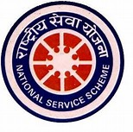

Annual Report
(2022-23 )

Compiler
Dr. Dilip B.Kamdi Dr. Ram Wasekar
N S S PROGRAME OFFICER N S S PROGRAME OFFICER

National Service Scheme Department of Rashtrapita Mahatma Gandhi Arts,Commerce and Science
College Saoli had organized numerous activities in the academic session 2022-23. These activities
Improves overall personality development of the students. In this session after( Covid-19) situation
Programmes are conducted Offlinemode .Our N.S.S. unit has 200 students,
The report is as follows.
1)Dr. Babasaheb Ambedkar Jayanti: 14thApril 2022
On14th April 2022 N.S.S. department celebrated Bharat Ratna Dr. Babasaheb Ambedkar Jayanti as
“Sanvidhan Vachan din”. Dr.A.Chandramoully Principal , preside over the function.Adv.
Santoshwarji will be the chief guest. Adv. Santoshwarji explained about importance of Sanvidhan
(constitution) in the todays changing scenario.

2) International Yoga Day :-21st June 2022

On 21st June 2022 International Yoga Day will be organized by N.S.S. department. Principal Dr.
A.Chandramoully presided over the function. “ Regular Yoga will strengthen the physical and mental
fitness” quoted by Dr. A. Chandramoully. Shri Roshan Tiwade Ex Student of the college will be the
chief guest of the function.He guided the Teachers and students on this occasion.

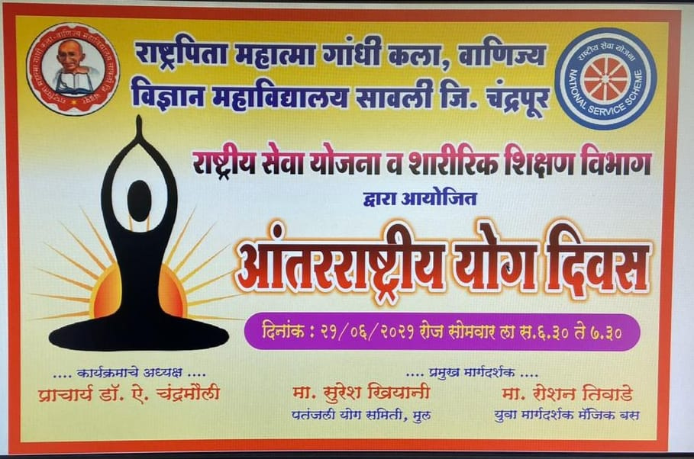

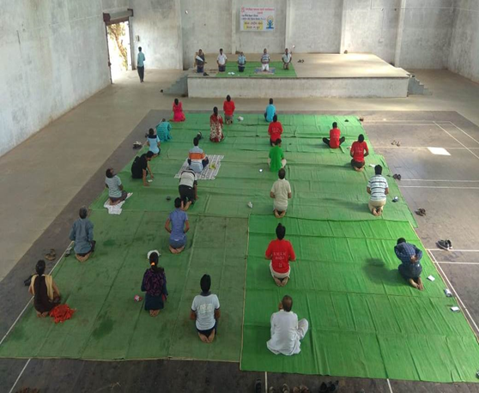 | 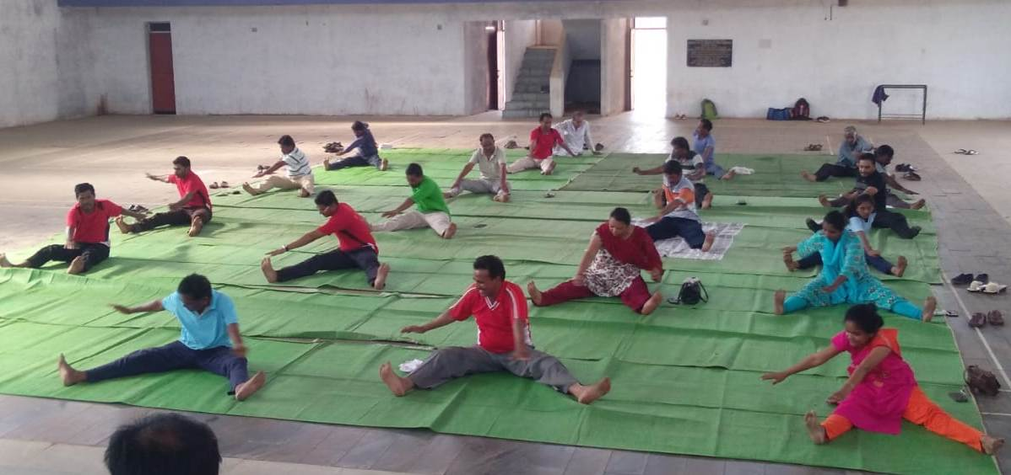

3)Tree PlantationProgram:
Tree Plantation activity will be organized by N.S.S. department on 10th August 2022in association with forest department Saoli . Senior Forest range Officer saoli, Professor and students of department of Botany as well as N.S.S. students and Program co-ordinator were present on this occasion .
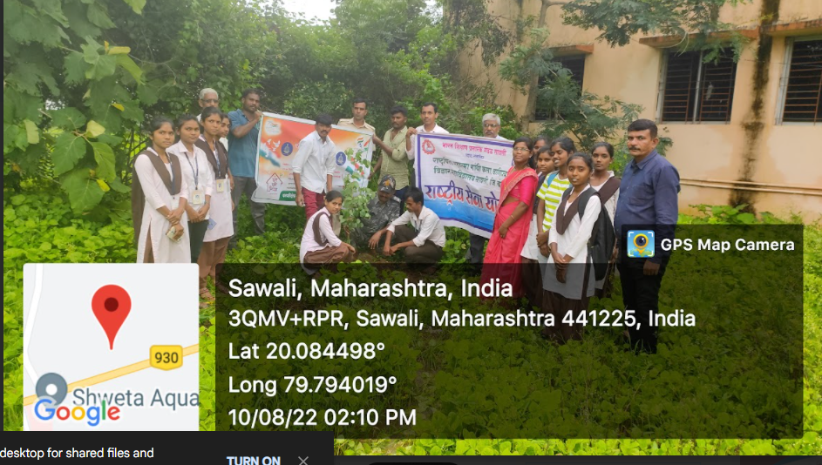

4) Covid -19 Vaccination Program:
Covid -19 vaccination programe will be organized by N.S.S. department on 11th August 2022in association with Health department Saoli . Around 60 students and Teachers get benefitted by this program they took booster dose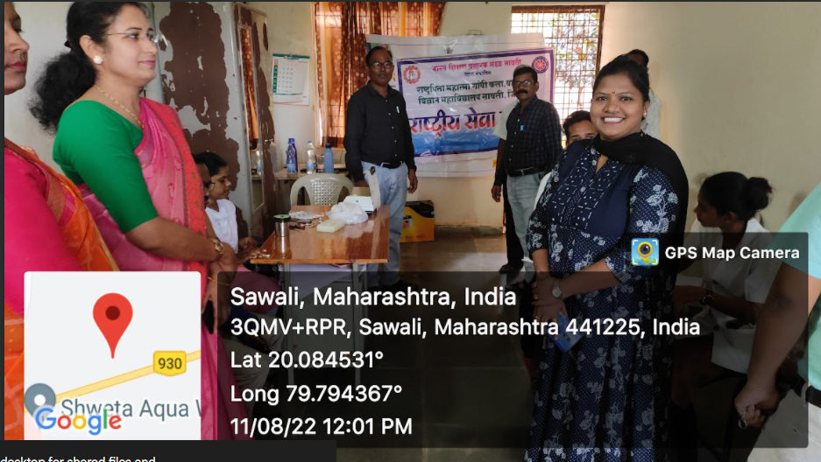

5)Youth Day and Cyber Security: Youth day will be celebrated on 12th August 2022 by N.S.S. department in association with police department Saoli and Taluka Bar association Saoli.. Adv.Gedam sir Taluka Bar association saoli and Head Ashishji Borkar ,police department saoli addressed the students on Cyber security.
6)Ghar, GharTiranga Abhiyan:From 10th August to 17th August GharGharTiranga Abhiyan will be celebrated on the occasion of Azadi ka Amrut Mahotsav, in association with Nagar panchayat Saoli.various activities were conducted during this period.
10thAugust 2022 Essay and Drawing competition.
11thAugust 2022 Allocation competition.
12thAugust 2022 Tree Plantation Program.
13thAugust 2022 Ghar,GharTiranga Rallywill be conducted. Tiranga Selfie point was arranged in the college.
14thAugust 2022 Debate competition in Tahasil office Saoli.
15thAugust 2022 Independence Day celebration.
17thAugust 2022 GroupRashtragan (National Anthem).
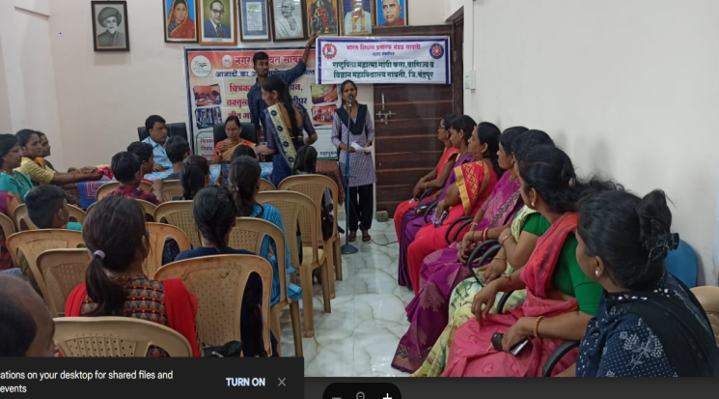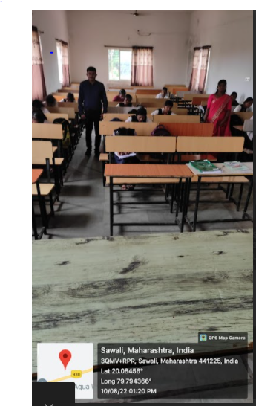

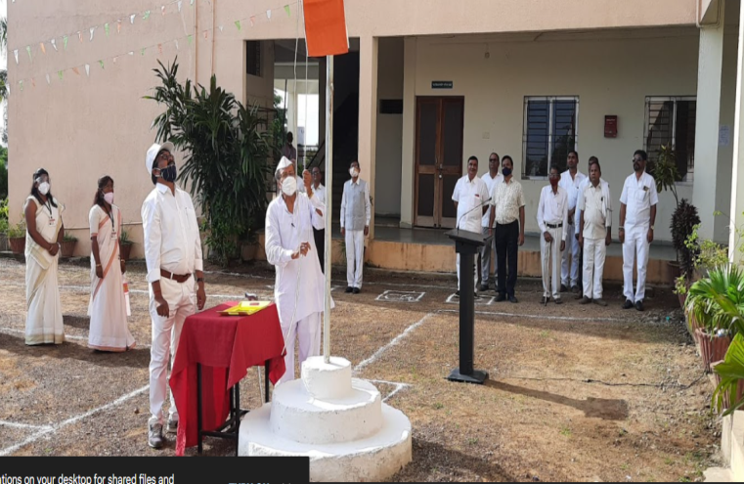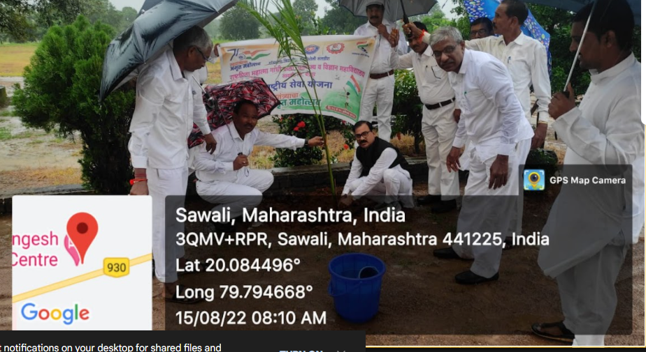

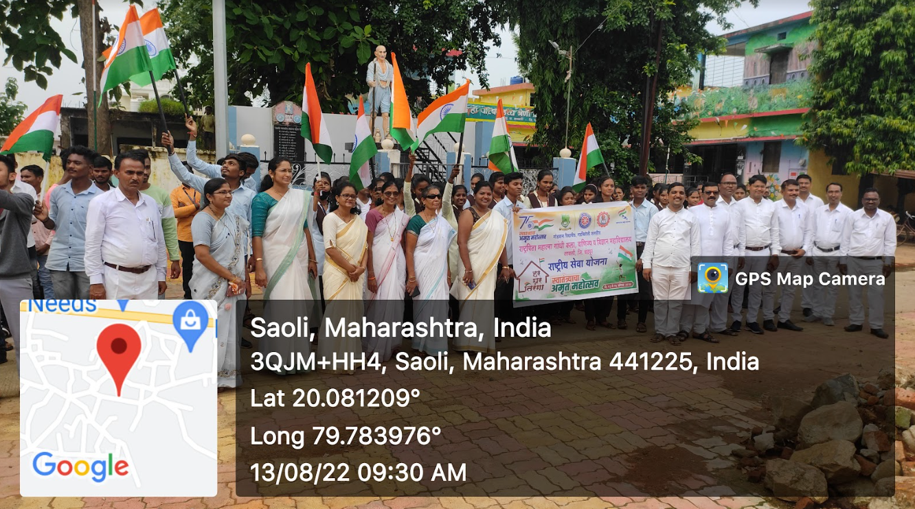
7) Road Safty and Legal guidance:N.S.S. Department and Bar Association Saoli jointly organize Legal guidance program to the college students. Adv.Ambatkar and Adv. Gedam sir deliver the speech on this occasion. Dr.Ashok Khobragade officiating principal, presided over the function.
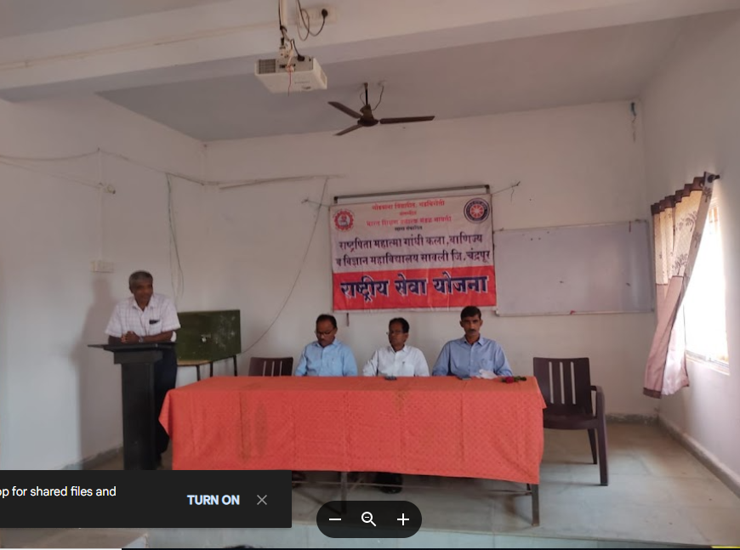

8)Navinyata Yatra (Innovation Journy ) . District skill development , Employment guidance centre Chandrapur organize the rally in association with N.S.S. students of the college on 29th August 2022 Co-ordinator of Skill development center guide the students about new innovation. It was very informative session for the students.
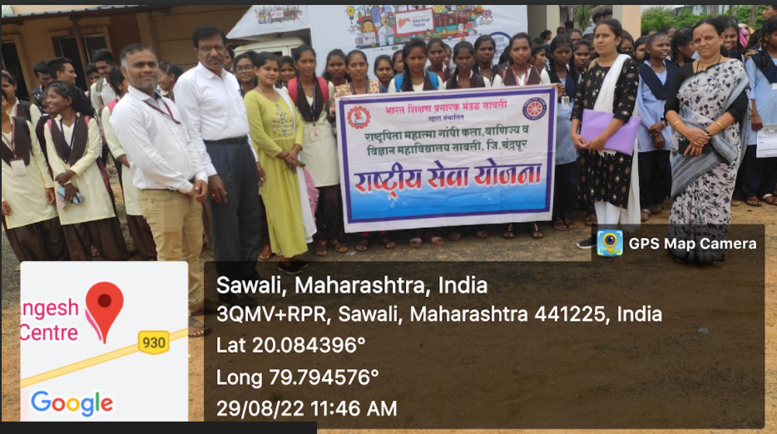
9) Teacher’s Day Program :Teacher’s day will be celebratedOn5thSeptember 2022 by N.S.S. department. Students actively participated and conducted self government program. Dr.Ashok Khobragade officiating principal presided over the function.
10) Blood Donation camp:N.S.S. department of Rashtrapita Mahatma Gandhi Arts, commerce and Science college saoli and Bharat shikshanprasarak mandal Saoli Jointly Organise Blood donation camp on 7th September 2022 on the occasion of Wamanrao Gaddamwarji saheb Jayanti ( founder president of the college ).
around 50 students and 15 teachers donated the blood. Shri VijaybhauWadettiwarji forest minister will be the chief guest .ShriSandeepbhau Gaddamwar president of Bharat shikshanprasarak mandal Saoli ,presided over the function.
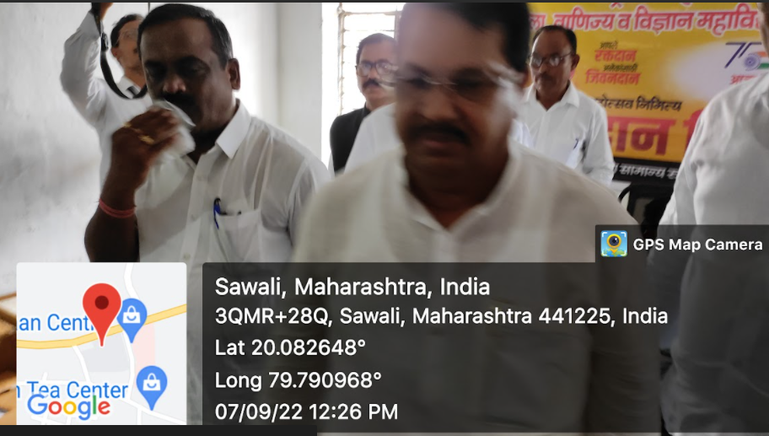
11)Mahatma Gandhi Jayanti: On 2nd October 2022 N.S.S. department celebrated Mahatma Gandhiji and Lal BahadurShastriJayanti as Non Violence Day and conducted the famous Bhajan program on Gandhiji’s life. Dr. Ashok Khobragade officiating Principal , preside over the function.
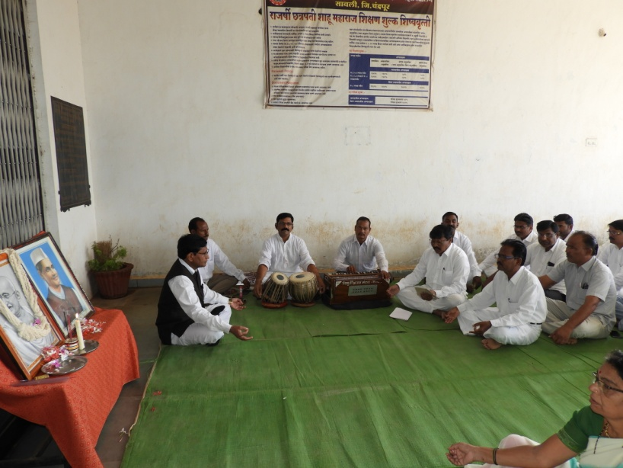  Bhajan on Gandhiji’s life | 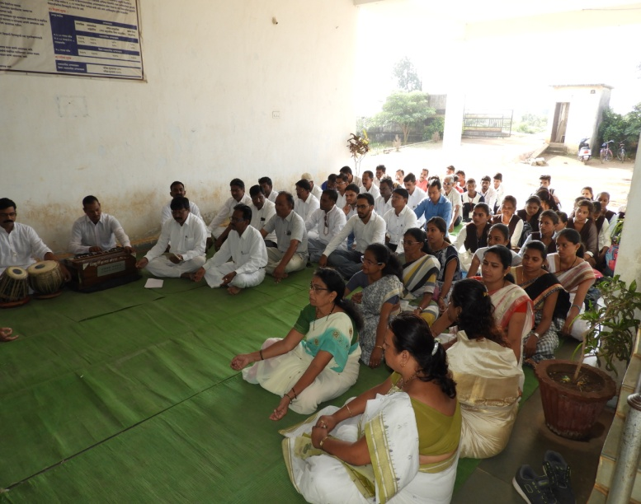 staff and students in the programme

12)Swaccha Bharat Abhiyan :“On The Occasion of SWATANTRYACHA AMRUT MAHOTSAV” “Swaccha Bharat Abhiyan” will be celebrated by N.S.S. department. Under this activity N.S.S. department students clean the college premises as well as Market area they collect the plastic garbage. Students take a oath for plastic free clean premises. On this movement Nagar Panchayat Saoli cooperate the student they also actively participated.

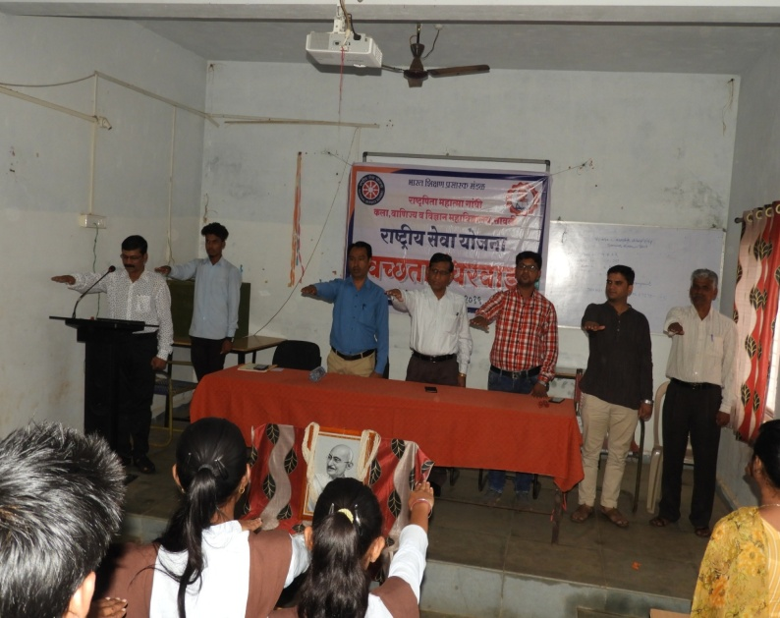  Taking oath on Cleanliness | 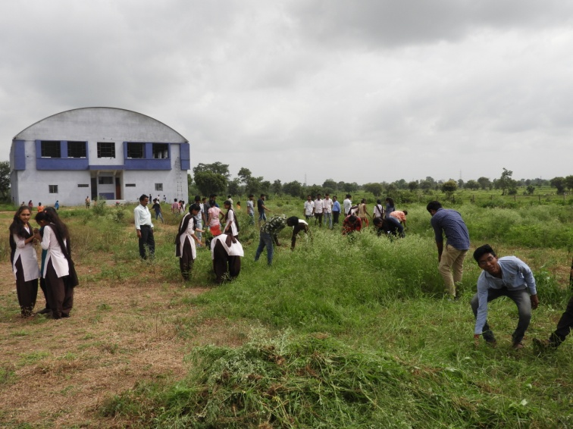  Cleanliness drive in the college campus

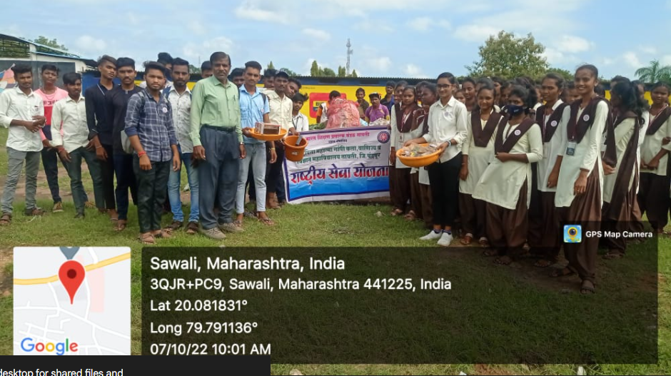

13) Rashtriya Ekta Divas: Rashtriya ekta Divas will be celebrated 0n the occasion of Sardar Wallabhbhai Patel jayanti 0n 31st october 2022 on this occasion students were taken National Integrity oath

14) SANVIDHAN DIN : Constitution day will be celebrated by N.S.S. department on 26 th Nov2022 .
Dr. Ashok Khobragade Principal express his views also importance of constitution day in todays scinerio.
He preside over the function .

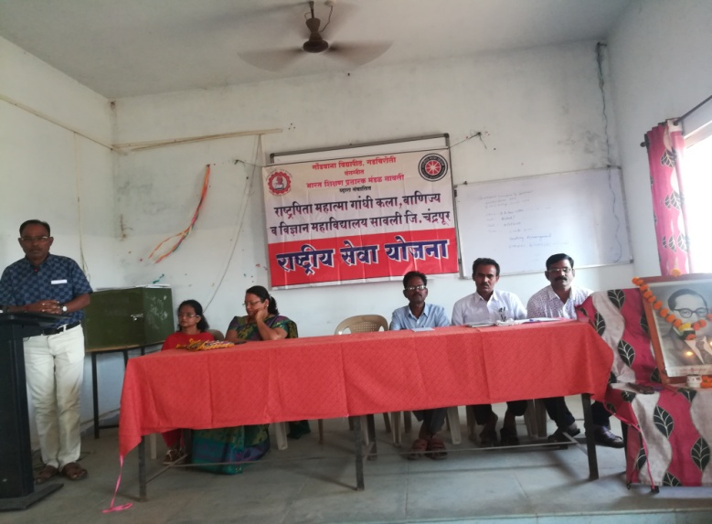
Dr A T Khobragade expressing the thoughts

15) Participation in AAVHAN camp:Kaviyitri Bahinabai Choudhari Uttar Maharashtra Vidyapith Jaigaon. Organise AAVHAN camp for N.S.S. students from 20th Dec to 29th Dec 2022. Two students Mast. Kishor Borkute and Ku.Anuradha Baddamwar of B.A.III participated in the camp.

16) Participation in UTKARSHA camp:N.S.S.volunteers Participated in UTKARSH camp organise by Solapur on 6th to 12th January 2023. 8 students participated in the camp.

17) International Youth Day::N.S.S. department organized International Youth Day program on 12th Jan 2023. Under this activity Dr. A.T.Khobragade principal of the college addressed the students Youth can chage todays scinerio by contributing in Nation buildinig.

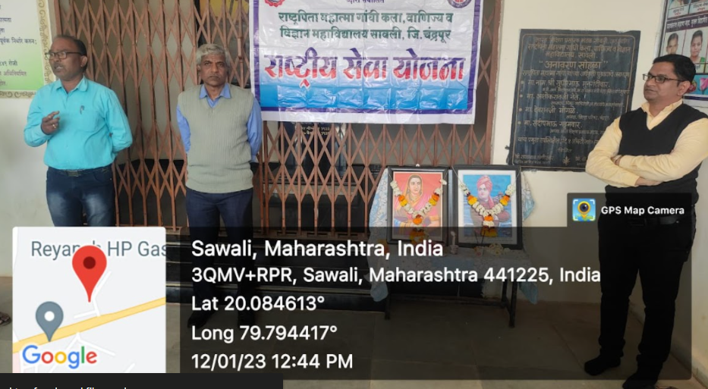

18) National Votrs Day :National voters day will be celabrated on 25th Jan 2023 by N.S.S. department. On this occasion National Voters day oath will be given to the students.

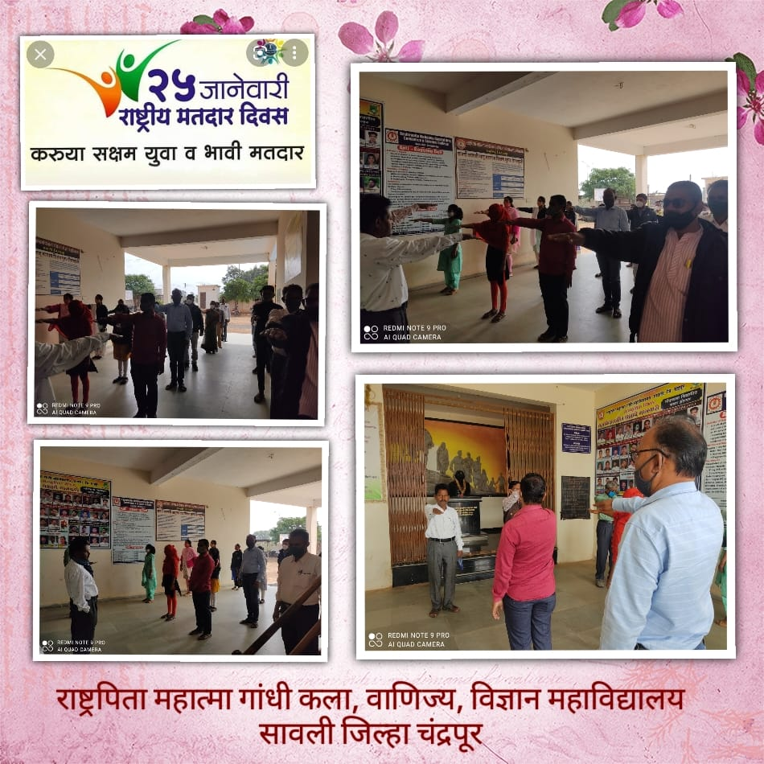

19) Hutatma Din :on 30th Jan 2023 on the Occasion of Hutatma Din and Rashtrapita Mahatma Gandhi death anniversary day students pay tribute toRashtrapita Mahatma Gandhi,Dr. A.T.Khobragade Prinipal will preside over the function. Mr. Prashant wasade were chief guest.

20) Treaking camp :N.S.S. department organized Treaking cum excurssion program on 15th feb 2023. Under this activity N.S.S volunteers participated in one day Treak at Satbahinicha Dongar which is situated at Ghodazari forest Range . Around 100 students participated in this camp.

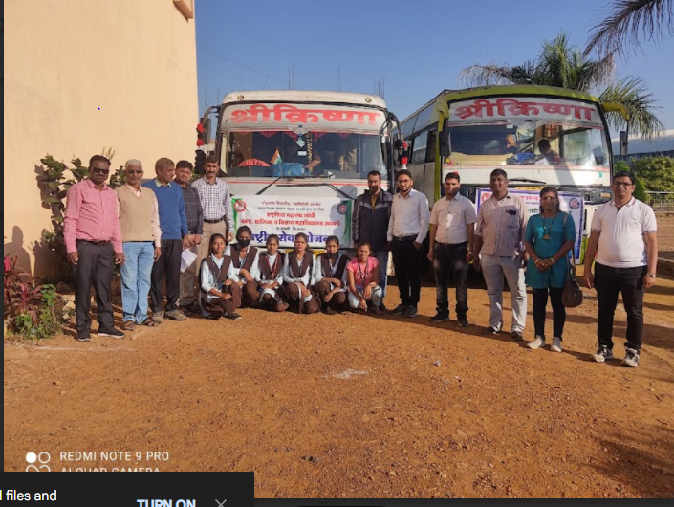

Special Camp 2022-23 :

N.S.S. department and Gram Panchayat Jibgaon Jointly organised special camp from 16thJanuary 2023to 22nd January 2023 in Zilla parishad school Jibgaon Ta.Saoli Dist. Chandrapur. On 16th January 2023, 11.00 a.m. all N.S.S. volunteers were present at special camp venue.They assembled for a camp preparation.Inaguration program were conducted on 17th January 2023, 2-00 p.m. Shri Anilji Swami Vice president,Bharat Shikshan prasarak mandal saoli will preside over the function.Honorable Purushottamji chudari sarpanch Gram panchayat jibgaon and Shri S.S. Yaykor Head Master Z.P.School Jibgaon will be the chief guest. Shri Anilji Swami address the student on the topic Youth Power. shri Purushottamji chudari address the students on environment and society.the programe will be concluded by national anthem.
Various activities were conducted during the special camp.

On 18th January 2023 1) Tree plantation under “Mazi Wasundhara Program”
(8.00 am to 11.00 am)
2) Scientific Attitude and Andhshraddha Nirmulan (2.00 p.m.)
(Lecture for students by Shri Vilas Nimborkar Gadchiroli.)
3) Cultural programm (8.00 to 10.00 p.m.)

19th January 2023 1) Cleanliness drive and donation of labour (8.00 am to 11.00 am)
2) Tarunyachya Vegalya Vata (2.00 p.m. to 4.00 p.m)
(Lecture by Dr. Savita Govindwar Gadchiroli.)
3) Cultural programme (8.00 to 10.00 p.m.)

20th January 2023 1) Cleanliness drive and donation of labour (8.00 am to 11.00 am)
2) Health Checkup on Sickle cell ( By Rupal Arun Urade, sickle
cell and thalesamia society chandraour . 2.00 to 4.00 p.m.)
3) Cultural programme (8.00 to 10.00 p.m.)

21st January 2023 1) Survey in Jibgaon on New Voter registration and Literacy
survey .
(8.00 am to 11.00 am)
2) Concluding programme in presence of Shri Rajabal Patil
Sangidwar Secretary Bharat Shikshan prasarak mandal saoli
(3.00 P.m.)
3) Certificate distribution
4) Fire camp (8.00 pm to 10.00 pm)

22nd January 2023 1) Camp Review(Recapitulation) and Departure (3.00 P.m.)

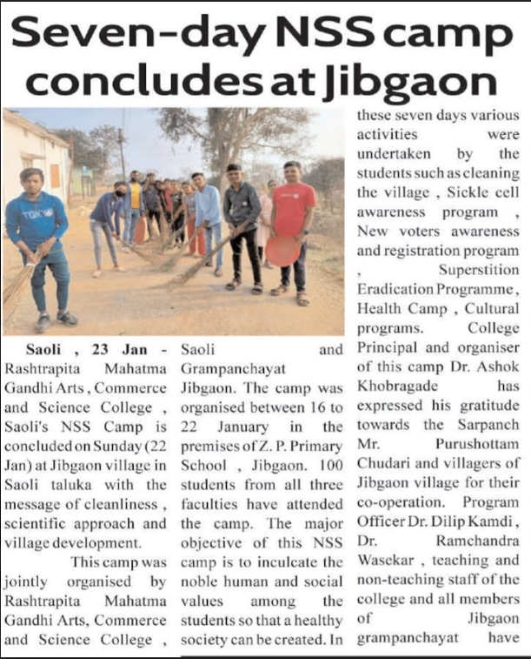

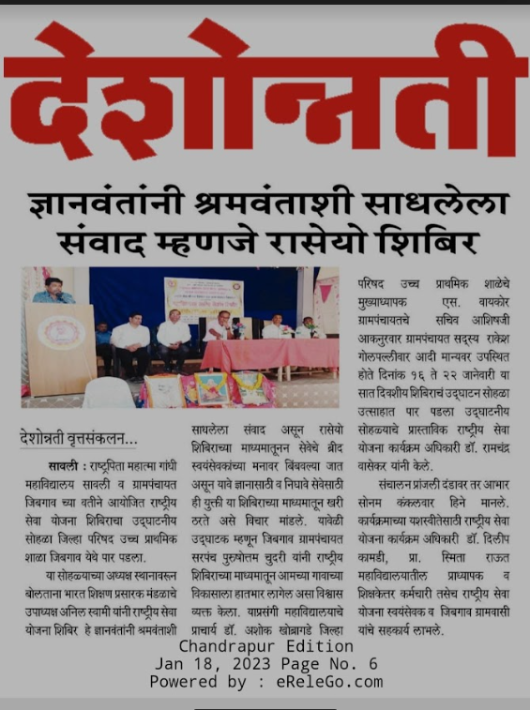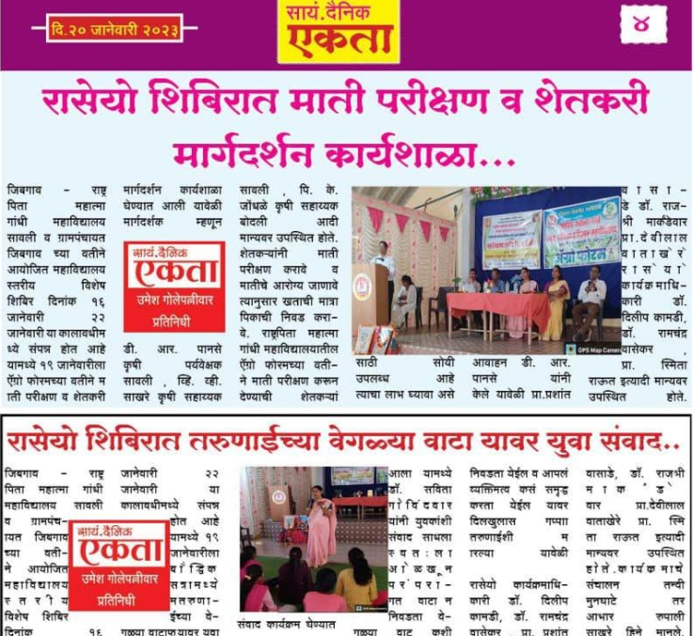
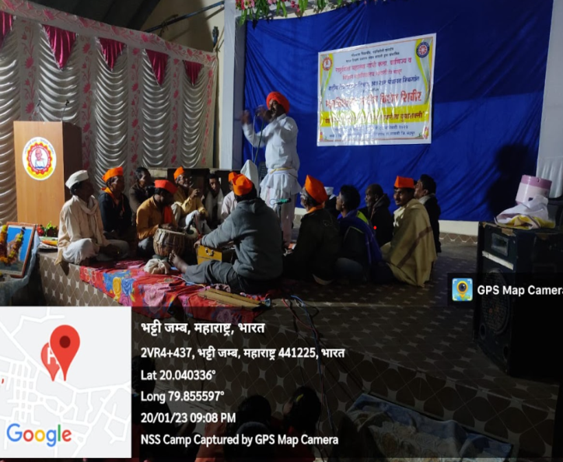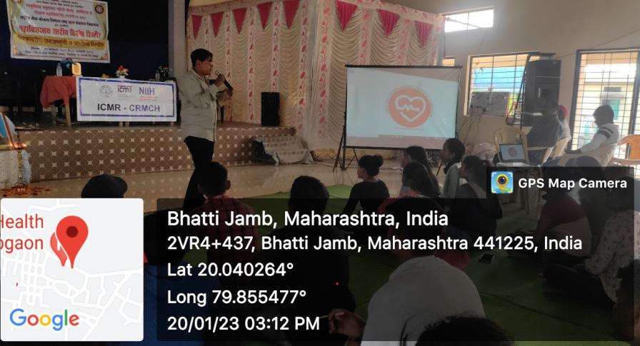

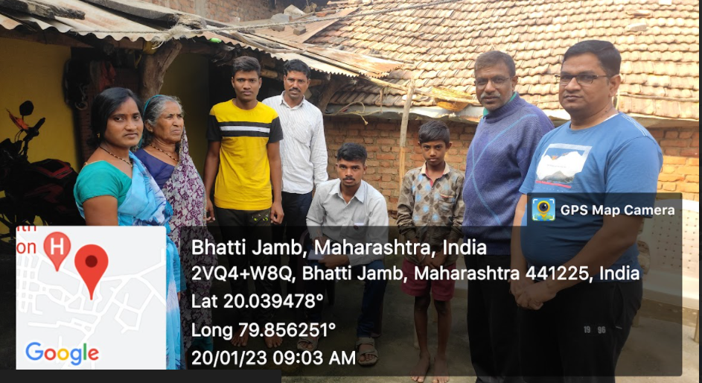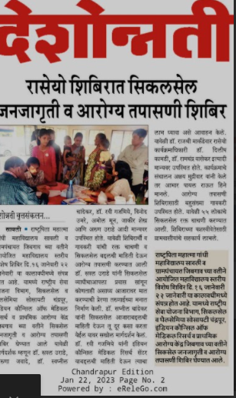

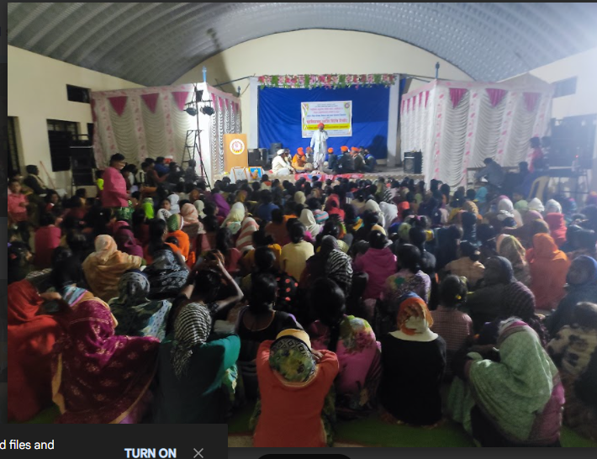

Some memorable events of N.S.S. Special camp 2022—23

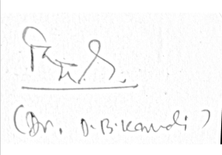
Programme Co-ordinator
(Dr. Dilip Kamdi )

